[1]

Two-wheel Balanced Robot

Weilun Peng, Da Li, and Jia Shi

*Abstract*— We propose a methodology of automating a two-wheel balanced robot to search and follow a path with a given destination in a constrained arena. We firstly design the controller to balance and move our robot without falling. Then we develop odometric dead reckoning to obtain the position of our robot. Then we implement a “Rotate, Translate, Rotate” RTR planner to make our robot go in a straight line between two waypoint. Finally, the path planning algorithm enables the robot to search a path avoiding the obstacles. All these functions can make robot automatically find and follow a path in a maze.

**Keywords: PID control, dead reckoning, RRT planner, path planning.**

# Introduction

Robotic manipulators are electronically controlled mechanism, consisting of multiple segments that perform tasks by interacting with the environment. They have been widely adopted to perform industry specific tasks such as picking and placing objects [1]. In this report, we present a 6 Degree-of-Freedom (DOF) robotic arm to autonomously detect, pick, move, align and/or stack cubes. To realize the goal, we decompose the task into four major milestones: gripper design, sensing, kinematics and planning with finite state machine.

The report is organized as follows: Section II describes the overview of the experimental setup used in this study. Section III describes the method studied for path smoothing and its performance evaluation. Section IV describes the final design of the gripper, design trade-offs and improvements made during the course of study. Section V describes the method we adapted to perform camera calibration and the algorithm implemented to detect and locate cubes. Section VI describes the derivation of forward and inverse kinematics and Section VII describes the algorithm for motion planning and implementation of FSM. Finally, The results of competition are showed and discussed in Section VIII and IX respectively.

# Methodology

## Controllers

Theoretically, the BalanceBot has an equilibrium pitch angle which points to upright, but it is an unstable system. Any input or response to the system will bring it away from the equilibrium pitch angle but the system does not have the ability to take itself back to equilibrium pitch angle. Therefore, we designed and implemented a pitch angle controller, a linear velocity controller, and a turning velocity controller to keep the BalanceBot system at the equilibrium pitch angle with desired linear and angular velocity. Also, position controller and heading controller were implemented to control BalanceBot to move to the desired position and turn to the desired angle.

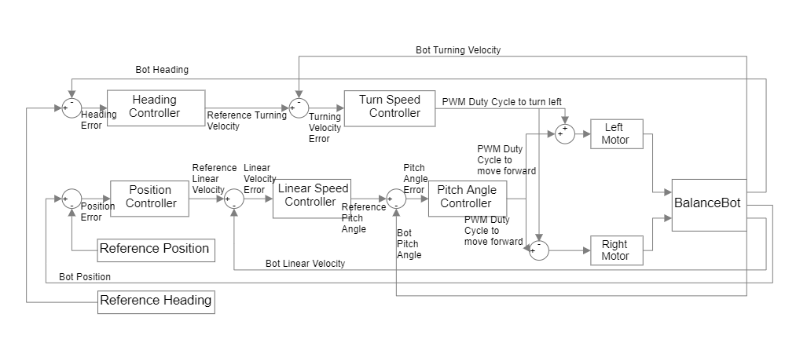

Fig.XX. Block diagram of cascade controller system

The block diagram of the cascade controller system are shown in Figure?. All the five controllers are PID controllers. The proportional term parameter, integral term parameter, and derivative term parameter will be reported in table ? (Maybe in the appendix?). To remove the effect of noisy signal, the derivative terms in all five controllers were filtered by a first order low-pass filter with a cut-off frequency of 40 Hz.

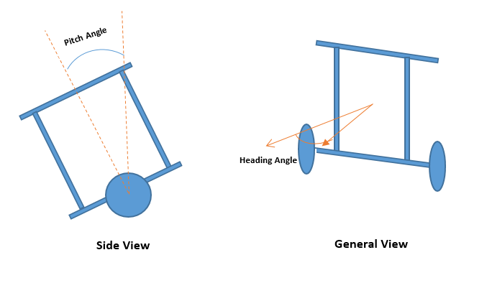

Fig.XX. Simple model of BalanceBot

As Shown in Fig. XX, The pitch angle is defined as the angle that the BalanceBot is tilting forward or backward by how much. The heading angle is defined as the angle that the BalanceBot is away from the initial facing direction by how much.

### Pitch Angle Controller: The Pitch Angle Controller took the reference pitch angle and the actual pitch angle of the BalanceBot which is given by IMU. Since the pitch angle given by IMU has a nonzero value when the BalanceBot was put straight up. We waited 15 seconds before it began to run to allow the IMU to initialize completely. Then we picked the first three pitch angle readings from IMU and use their average as the pitch angle offset of the current operation. We found that the raw pitch angle reading was not continuous at the upright position. Hence, we subtracted 2π when the reading was greater than 0, which made the pitch angle change continuously and symmetric when the BalanceBot bent forward and backward. The Pitch Angle Controller took error which was generated by subtracting the real pitch angle from the reference pitch angle as input and gave the duty cycle of PWM as output to control the motors to keep the BalanceBot at balance position during transition, rotation or standing. The proportional, integral, and derivative parameters will be reported in table ?

### Linear Velocity Controller: The Linear Velocity Controller took the reference linear velocity and the actual velocity that the BalanceBot is moving forward with. The actual linear velocity was from the readings of encoders of left and right motors. Before each update, the encoders were reset to 0, which made the readings of encoders the actual values that changed during the period. To compute the linear velocity, we used the equation:

To calculate left and right speeds in RPM. Then the equation:

was used to calculate the linear velocity of the BalanceBot in m/s. Then it was subtracted from the desired linear velocity, which produced the error as the input for the Linear Velocity Controller. At last, the Linear Velocity Controller gave out the desired pitch angle as output. The proportional, integral, and derivative parameters will be reported in table ?

### Turning Velocity Controller: Similarly, the Turning Velocity Controller took the same logic of implementation as the Linear Velocity Controller. It took the reference turning velocity and the actual angular velocity that the BalanceBot was turning to the left. The left and right motor speeds were generated through the same equation above. The calculation of turning speed (in rad/s) was by the equation:

Then, the difference between desired turning velocity and the actual value was taken as the input of Turning Velocity Controller and it gave the PWM duty cycle as output. This duty cycle could control the BalanceBot to turn at desired angular velocity to the left if we subtracted it from the duty cycle of left motor and added it to the duty cycle of right motor. When the output was positive, it controlled the BalanceBot to turn to the left. When it was negative, the BalanceBot was controlled to the right. The proportional, integral, and derivative parameters will be reported in table ?

### Position Controller: The Position Controller controlled the BalanceBot to stay or move to the desired position. It took the distance from the current position to the desired position as input and generated the desired linear velocity (in m/s) as output. The input distance (in m) was calculated by the equation:

The proportional, integral, and derivative parameters will be reported in table ?

### Heading Controller: The Heading Controller took the difference between the desired heading and the current real heading to control the BalanceBot to turn to the desired heading angle. The desired heading angle is computed by the equation:

The current heading angle was obtained from odometry model. To clamp the heading angle difference and make it continuous when the BalanceBot turned backwards, we had come up with a strategy to handle the situation that if the absolute value of the angle difference is greater than π. When the value of the angle difference is greater than π, we made the angle difference negative and plus π to it. When the value of the angle difference is less than –π, we made it to positive and subtracted π from it. Also, we had the same strategy to handle the actual heading angles. After this process, the result from actual heading angles would be subtracted from the difference of heading angle, which would prevent the difference of heading angle from going beyond the interval from –π to π or discontinuous. The proportional, integral, and derivative parameters will be reported in table ?

|  |  |  |  |
| --- | --- | --- | --- |
| Controllers | Kp | Ki | Kd |
| Pitch Angle Controller |  | 20.0 | 0.15 |
| Linear Velocity Controller |  | 0.0 | 0.005 |
| Turning Velocity Controller | 7000.0 | 0.0 | 600.0 |
| Position Controller  Heading Controller | 1.0  0.00008 | 0.0  0.0 | 0.01  0.000001 |

Table XX. The parameters of controllers in BalanceBot

## Path Planning

In this part, we developed a planner to make robot move to the desired place without collision. The planner is a waypoint generator based on A* search algorithm. The waypoints are also decided by using the real-time coordinates from odemetry and optitrack.

### Description of algorithm: In order to complete the task 4, we used A* search algorithm to find the path. Comparing with Dijkstra's algorithm, A* search algorithm is much faster by usi ng best-first search to speed things up.

In this competition, we conisiderred our robot as a point and all obstacles as cirlces with radius. With the range of radius, the collision will happen. So in this task, we set the radius of obstacles as half of the maximum width of the robot and the radius values are shown in Table xx.

With the configuration space of the world, an A* search algorithm was used to construct a tree of paths starting from start node, expanding paths one step at a time, until one of its paths ends at the predetermined goal node. At each iteration of its main loop, A* selectted the path by using approximate total path cost, which is to minimize an evaluation function:

Where n is the last node/point on the path, is the cost of the path from the start node to n, and is a heuristic function that estimates cost from n to the goal. is the estimated total cost of path through n to goal [2].

In this task, we define as the Euclidean distance from the position of last node n to goal shown in Eq. xx and this heuristic is admissable since it never overestimated the cost to reach the goal.

Where () and () are the coordinates of current and goal node, respectly.

With this heauristic, we can calculate estimated total cost of path and use priority queue to perform the repeated selection of minimum estimated cost nodes to expand. So at each iteration, the node with the lowest is removed from the queue, and the and values of its neighbors are updated accordingly, and these neighbors are added to the queue. The algorithm continues until a goal node has a lower value than any nodes in the queue or until the queue is empty. The value of the goal is then the length of the shortest path, since at the goal is zero in an admissible heuristic. So The A* search algorithm for reaching a single destination is summarized in Algorithm 1.

|  |
| --- |
| **Algorithm 1** Algorithm of path planner based on A* search algorithm |
| **while** () &&  dequeue:    **for** each *nbr* in not visited(adjacent())  **if** !*collision(nbr)*  enqueue: *nbr to*  **if**        e**nd if**  e**nd for**  e**nd while** |

### Gate Waypoint Placing: Since we are given the position of left and right gates, the direction of passing through the gate is fixed. So that we can define two waypoints placed on both sides of the gate as entering point and exiting point.

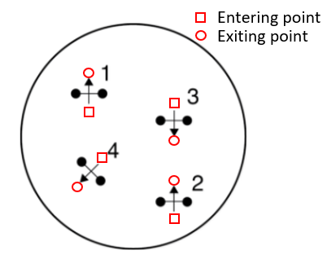

Fig. xx: An example of gate configuration. Square represent entering point and circle is exiting point.

The entering and exiting waypoints are calculated by using the coordinates of left and right gate shown in following equations:

Where is the maximum width of the robot and () and () are entering and exiting waypoints we will set.

### Final implementation: The robot moves from the entering point to exiting point to pass through the gate. Once the robot reaches the exiting point, the gate will be open, which will be not considered as obstacles in the rest of path-finding. Then we will use A* search algorithm to find a path from last exiting point to next entering point. So in the competition, there are 4 gates in total, So 4 entering points and 4 exiting points are generated together with starting point and goal point. And between each adjacent waypoint, we used RTR planner to go in a straight line. We coded A* search algorithm in Python to generated waypoints data file for the competition and the path is shown in the result.

# results

## Controllers

### Impulse Response of Pitch Angle

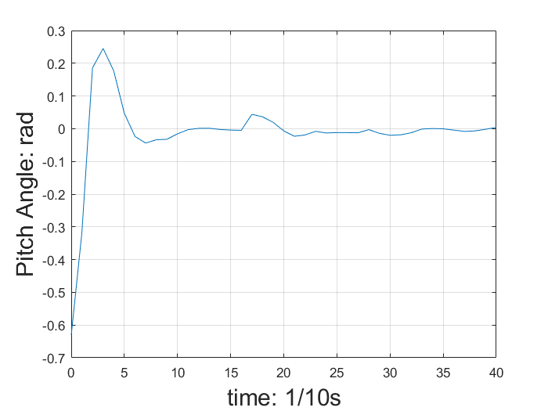

Fig. XX Impulse Response of Pitch Angle

As shown in Fig. XX, the impulse response of pitch angle has an overshoot towards the impulse signal. But the pitch angle goes back to equilibrium in about 1 second. Also, no other overshoot is generated. If we judge the response by the performance saw by our eyes, we find that the BalanceBot can go back to straight up position in a time of approximately 1 second with oscillation no more than once. Then it will keep at equilibrium position without going away from it.

### Impulse Response of Linear Velocity

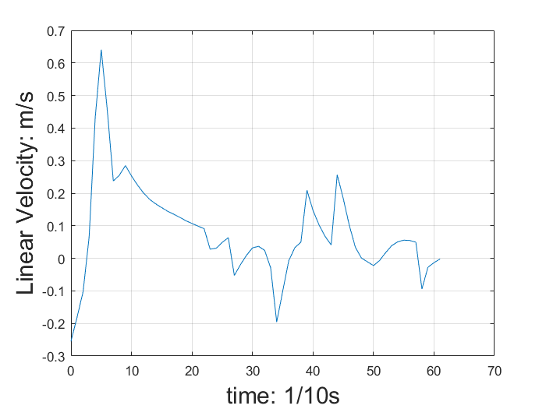

Fig. XX Impulse Response of Linear Velocity

As shown in Fig. XX, the impulse response of linear velocity has an overshoot larger than the amplitude of input impulse and it will oscillate around the equilibrium point more than once. The system will go back to stable in more than 6 seconds. Compared to the Pitch Angle Controller, the Linear Velocity Controller generates larger overshoot and larger settling time. According to the impulse response, the Linear Velocity needs to be tuned again.

### Impulse Response of Turning Velocity

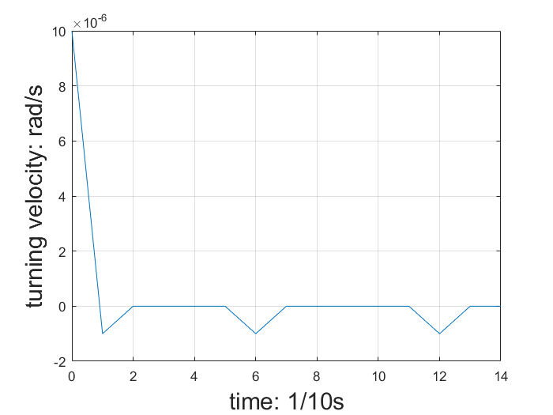

Fig. XX Impulse Response of Turning Velocity

As shown in Fig. XX, the impulse response of turning velocity has small overshoot which is just 10% of the amplitude of input signal. Also, its settling time is just 0.2 second. It means that the angular can be stabilized in just 0.2 second and will not go unstable. Among all three controllers, Turning Velocity Controller has the smallest overshoot and the smallest settling time.

## Path planning

Based on the gate positions obtained from optitrack, we firstly run a Python simulation to generate the waypoints in the whole path. The gate positions are shown in following table.

TABLE xx

The position of each gates

|  |  |  |
| --- | --- | --- |
| # of gate | Left [m] | Right [m] |
| 1 | (0.062, -0.064) | (0.062, -0.001) |
| 2 | (-0.061, 0.065) | (0.002, 0.062) |
| 3 | (-0.064, -0.061) | (-0.121, -0.063) |
| 4 | (0.001, -0.123) | (0.001, -0.061) |

The result of path is shown in Fig. xx.

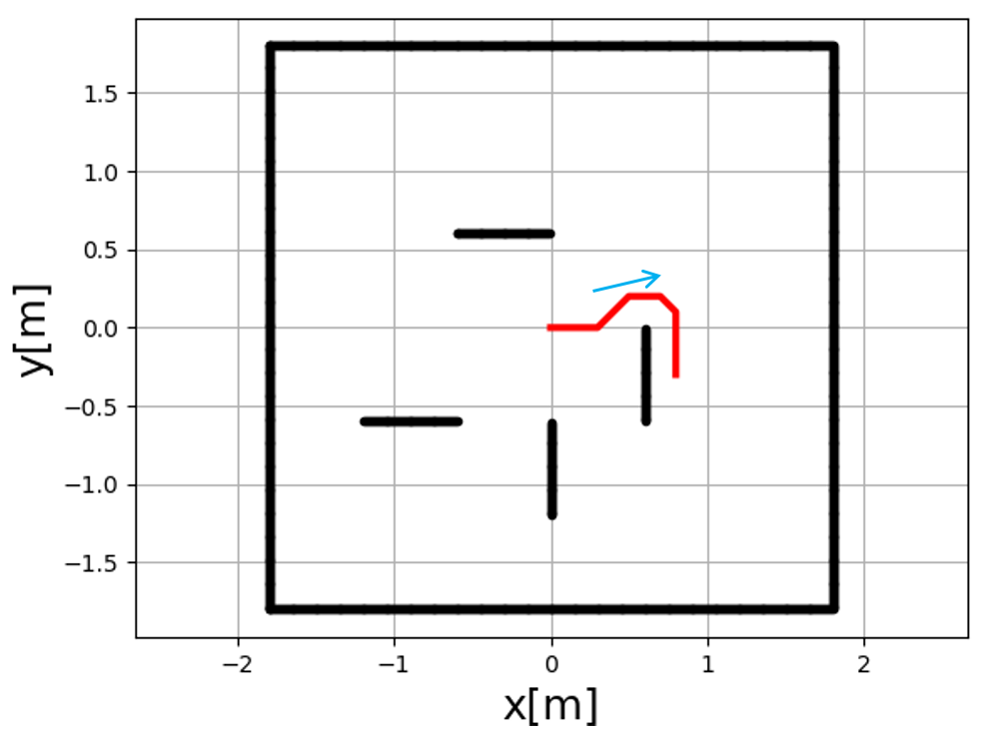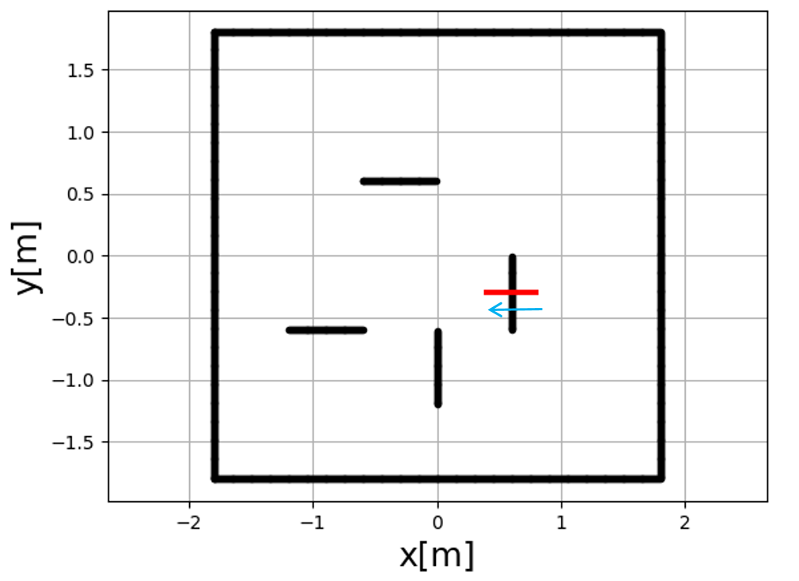

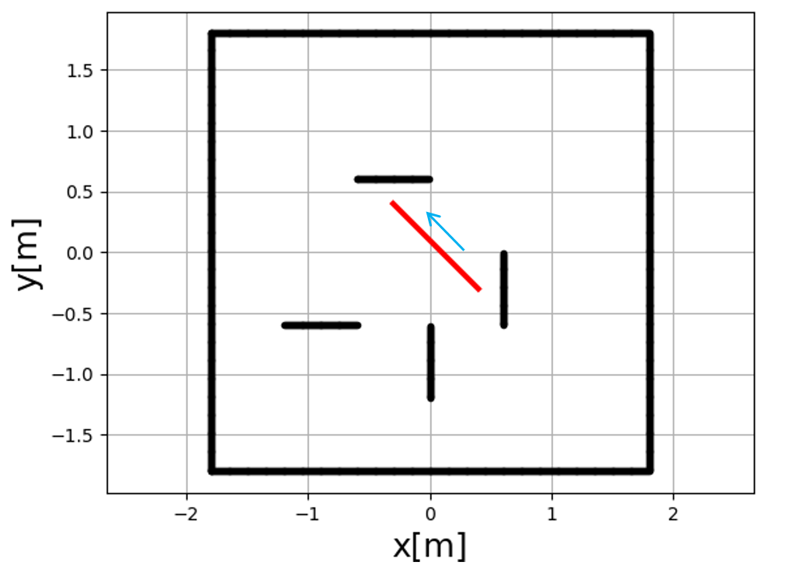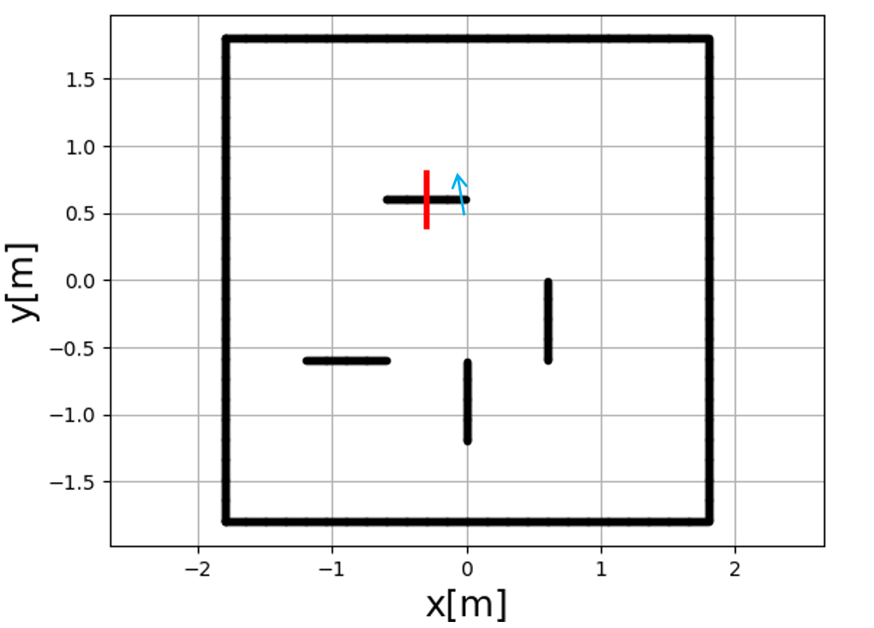

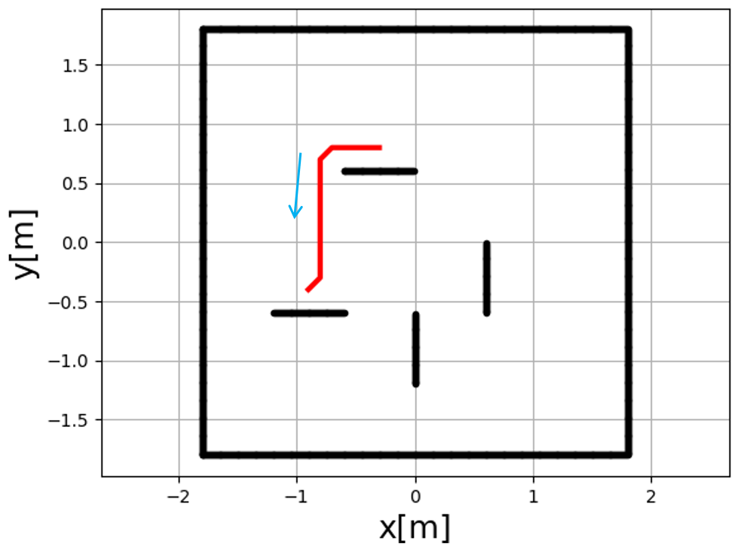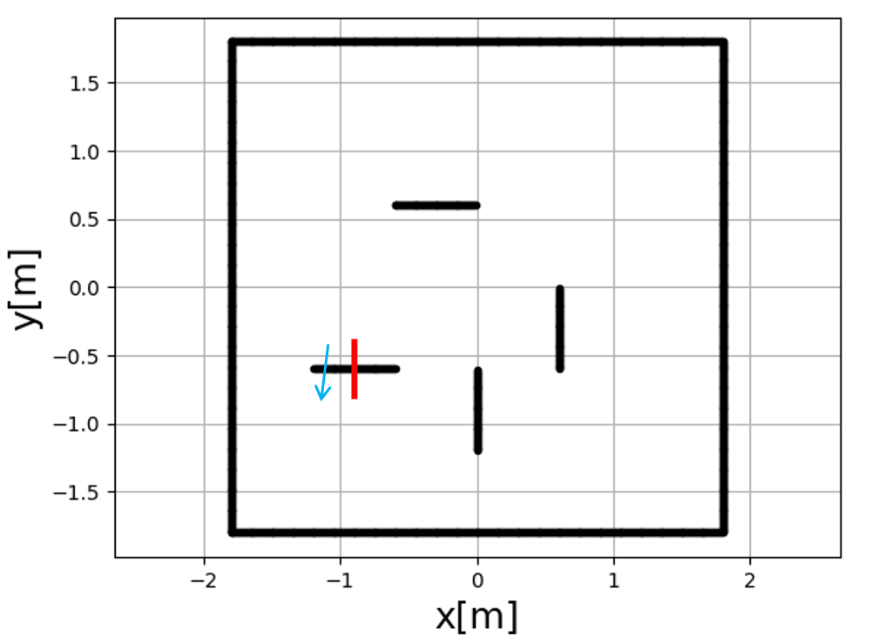

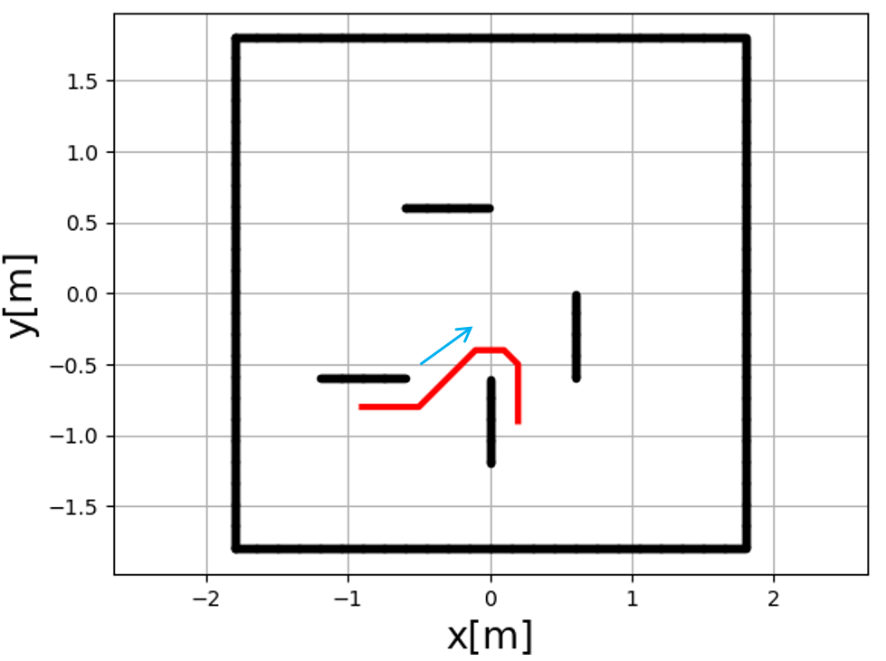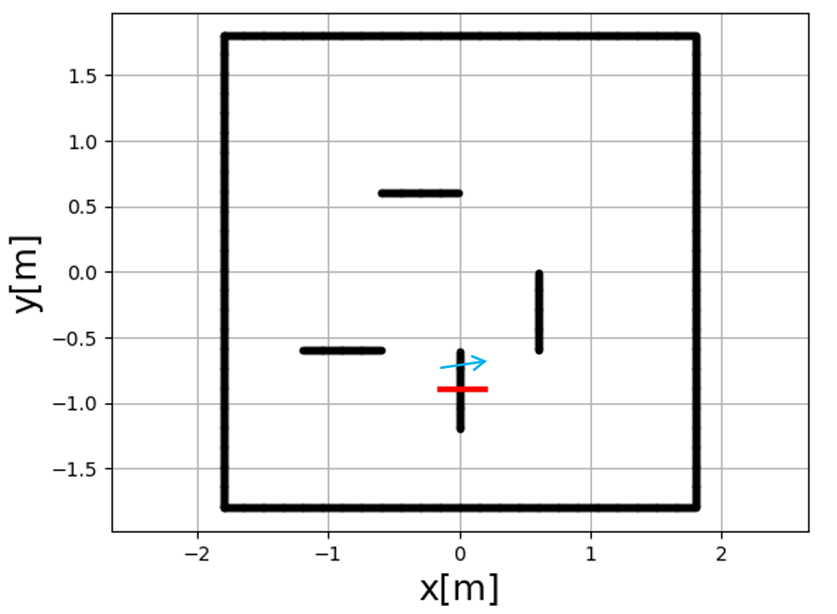

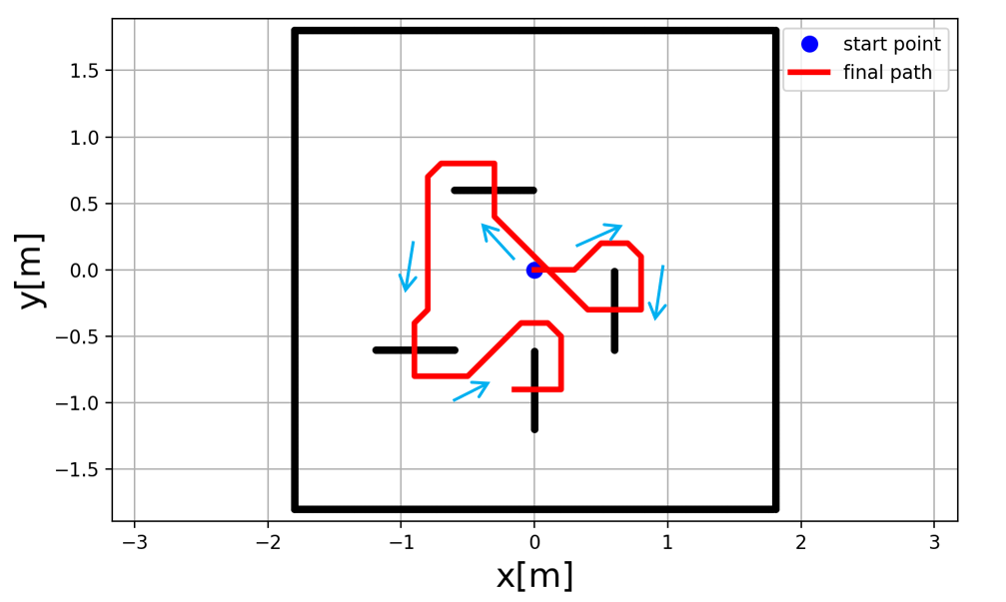

Fig. xx: 8 pieces of partial paths and the whole path

# Conclusion

References

|  |  |
| --- | --- |
| [1] | ROB550. (2018) Balancebot description. |
| [2] | Borenstein, Johann, and Liqiang Feng. "Gyrodometry: A new method for combining data from gyros and odometry in mobile robots." Robotics and Automation, 1996. Proceedings., 1996 IEEE International Conference on. Vol. 1. IEEE, 1996. |
| [3] | Borenstein, Johann, and Liqiang Feng. "Measurement and correction of systematic odometry errors in mobile robots." IEEE Transactions on robotics and automation 12.6 (1996): 869-880. |
| [4] | Modeling a simple DC motor, P. Gaskell, 2018 |
| [5] | Lerner, Jürgen, Dorothea Wagner, and Katharina Zweig, eds. Algorithmics of large and complex networks: design, analysis, and simulation. Vol. 5515. Springer, 2009. |

# Appendix A: camera calibration

## A.1 Depth function identification

Raw data used to identify the depth function depicted in Figure 6.

TABLE A.1

BOM

|  |  |
| --- | --- |
| Part name | # of parts |
| Beaglebone Green | 1 |
| Mobile Robotics Cape | 1 |
| 3 cell, 1500mAh Lithium Polymer battery | 1 |
| battery monitor | 1 |
| 20.4:1 Metal Gearmotor 25Dx50L mm MP 12V with 48 CPR Encoder | 2 |
| DRV8801 Single Brushed DC Motor Driver Carrier | 1 |
| MPU9250 IMU | 1 |
| DSM Satellite receiver | 1 |
| Acrylic board | 1 |
| Metal pillar | 6 |
| Robot wheel | 2 |
| M3 screws | 40 |

## A.2 Depth and RGB camera association

Setup image for depth and RGB camera association, dots are the positions used for calculation and detailed pixels values in RGB and depth camera are documented in Table A.2 below.



TABLE A.2

data for depth and RGB camera association

|  |  |  |
| --- | --- | --- |
| # of points | RGB camera  (x, y) | Depth camera  (x, y) |
| 1 | (144, 93) | (147, 70) |
| 2 | (140, 448) | (147, 456) |
| 3 | (204, 211) | (211, 196) |
| 4 | (203, 270) | (210, 260) |
| 5 | (201, 325) | (210, 326) |
| 6 | (321, 155) | (340, 133) |
| 7 | (318, 387) | (340, 389) |
| 8 | (435, 211) | (468, 197) |
| 9 | (434, 268) | (470, 259) |
| 10 | (436, 330) | (471, 325) |
| 11 | (498, 93) | (530, 69) |
| 12 | (499, 450) | (538, 456) |

## A.3 Extrinsic matrix calibration

TABLE A.3

data for extrinsic matrix calibration

|  |  |  |  |
| --- | --- | --- | --- |
| # of points | World coord.  (x, y, z)[mm] | # of points | World coord.  (x, y, z)[mm] |
| 1 | (200, -200, 0) | 9 | (100, -100, 152) |
| 2 | (0, -200, 38) | 10 | (0, -100, 38) |
| 3 | (-200, -200, 76) | 11 | (-100, -100, 76) |
| 4 | (-200, 0, 114) | 12 | (-100, 0, 114) |
| 5 | (-200, 200, 0) | 13 | (-100, 100, 152) |
| 6 | (0, 200, 38) | 14 | (0, 100, 38) |
| 7 | (200, 200, 76) | 15 | (100, 100, 76) |
| 8 | (200, 0, 114) | 16 | (100, 0, 114) |

Algorithm for extrinsic matrix calibration:

With both intrinsic matrix and depth function, Eq. (1) can be written as

(A.1)

where the only unknown is the extrinsic matrix that describes the coordinate transformation from 3D world frame () to 3D camera frame (). Hence, the dimensions for and matrices in Eq. (A.1) are 3 by 3 and 3 by 1 respectively. This implies that there are a total of 12 parameters to be estimated to reconstruct the extrinsic matrix. For a pair of known correspondence, we have three equations

(A.2)

where the superscript indicates the pair. For parameter estimation, Eq.(3) can be rearranged as

(A.3)

where consists of the parameters in extrinsic matrix. With multiple pairs of known correspondences [7], we can expand Eq.( A.3) as

and parameter can be determined using least square estimation , where

# Appendix block detection

Training image

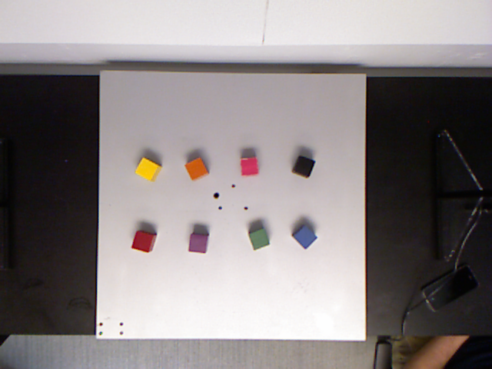

Validation images

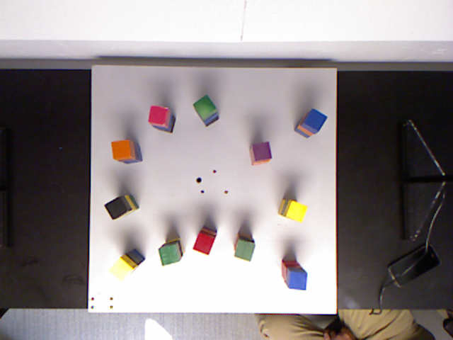

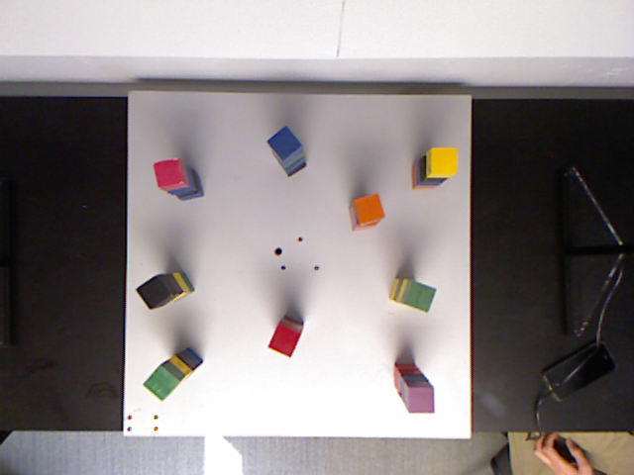

Testing images

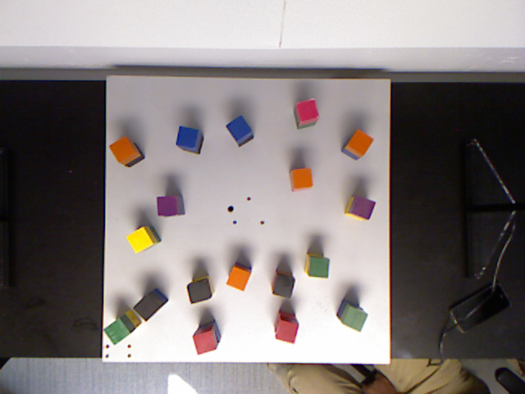

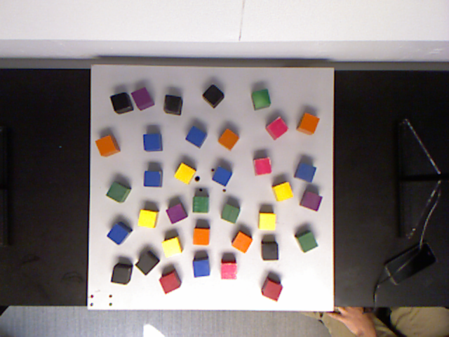

TABLE B.1

color thresholds

|  |  |  |  |  |
| --- | --- | --- | --- | --- |
| Color | H | S | V | L |
| Black | (0, 255) | (0, 80) | (0, 90) | (0, 100) |
| Red | (150, 200) | (100, 200) | (0, 255) | (0, 100) |
| Orange | (10, 40) | (0, 255) | (0, 255) | (0, 255) |
| Yellow | (20, 30) | (0, 255) | (0, 255) | (0, 255) |
| Green | (40, 100) | (0, 255) | (0, 255) | (0, 255) |
| Blue | (80, 130) | (0, 255) | (0, 255) | (0, 255) |
| Violet | (100, 140) | (0, 255) | (0, 255) | (0, 255) |
| Pink | (120, 255) | (0, 255) | (0, 255) | (120, 255) |
| Color | R | G | B |  |
| Black | (0, 255) | (0, 255) | (0, 255) |  |
| Red | (0, 255) | (0, 100) | (0, 100) |  |
| Orange | (125, 255) | (60, 140) | (0, 50) |  |
| Yellow | (0, 255) | (150, 255) | (0, 255) |  |
| Green | (0, 150) | (50, 255) | (0, 255) |  |
| Blue | (10, 100) | (0, 255) | (100, 255) |  |
| Violet | (100, 255) | (0, 255) | (100, 255) |  |
| Pink | (180, 255) | (0, 150) | (0, 255) |  |

# Appendix c: finite state machine design

## Detailed finite state machine

|  |
| --- |
| **Run_state_machine(event_num):** n_trial = 0 **Detecting all the blocks on the board:** Generate a color_list, loc_list  if no block detected:  to state 8  else:  to state 2 **Analyzing board situation based on event_num:** According to rules specified by event, identify the blocks need to be picked  If no block need to be picked or n_trial > n_max :  to state 8  else:  generate color_list_pick, loc_list_pick from color_list, loc_list **Generating target locations, assign orders:** For i = 1 to N in loc_list_pick:  compute loc_list_place[i]  Reorder loc_list_pick, loc_list_place according to its color info (only for event 3 and 4), to state 4  For i = 1 to N in loc_list_pick: **Compute solution of inverse kinematic:** Compute solution of inverse kinematic given loc_list_pick[i], loc_list_place[i]:  If no solution exists:  to state 7  else:  Compute angle_pick, angle_place then to state 5 **Generating way points:** Given angle_pick, angle_place, generates angle_transition for the arm, then to state 6 **Move one block to target location:** Given the way points, perform sequential movements on the arm and the gripper to pick and place the block **Checking if all blocks have been moved:** If all blocks have been moved:  n_trial += 1  to state 1  else:  to state 4  endfor **Terminate the event and reset arm position:** Close gripper and reset arm position to vertical pose  Return status of the event |

## Detailed Motion Sequence

For simplicity, the motors are abbreviated as: B (base), S (shoulder), E (elbow), W (wrist), G1 (grip1), G2(grip2). We define the following motion as:

Open gripper: G2 = 90

Close gripper: G2 = 0

Rotate gripper: G1 = 15 or -75

Lift to safety: move S 50 towards 0 direction

Move to pick: move the arm in sequence of B->E->S->W

Move to place: move the arm in sequence of B->S->E->W

Move at same: move B, S, E, W at same time to target

For event 1 to event 4, the motion plan is set to be: open gripper -> move to pick -> close gripper -> lift to safety -> move to transition -> move to place -> open gripper -> lift to safety -> move to transition

For event 5, the motion plan is set to be: open gripper -> move to pick -> close gripper -> lift to safety -> move to transition -> rotate gripper -> move to place -> open gripper -> move at same to transition -> move to transition

The designed motion plan was able to accomplish pick and place of block without generating interference with other objects during the experiments.

# Appendix d: cad drawing

Connector

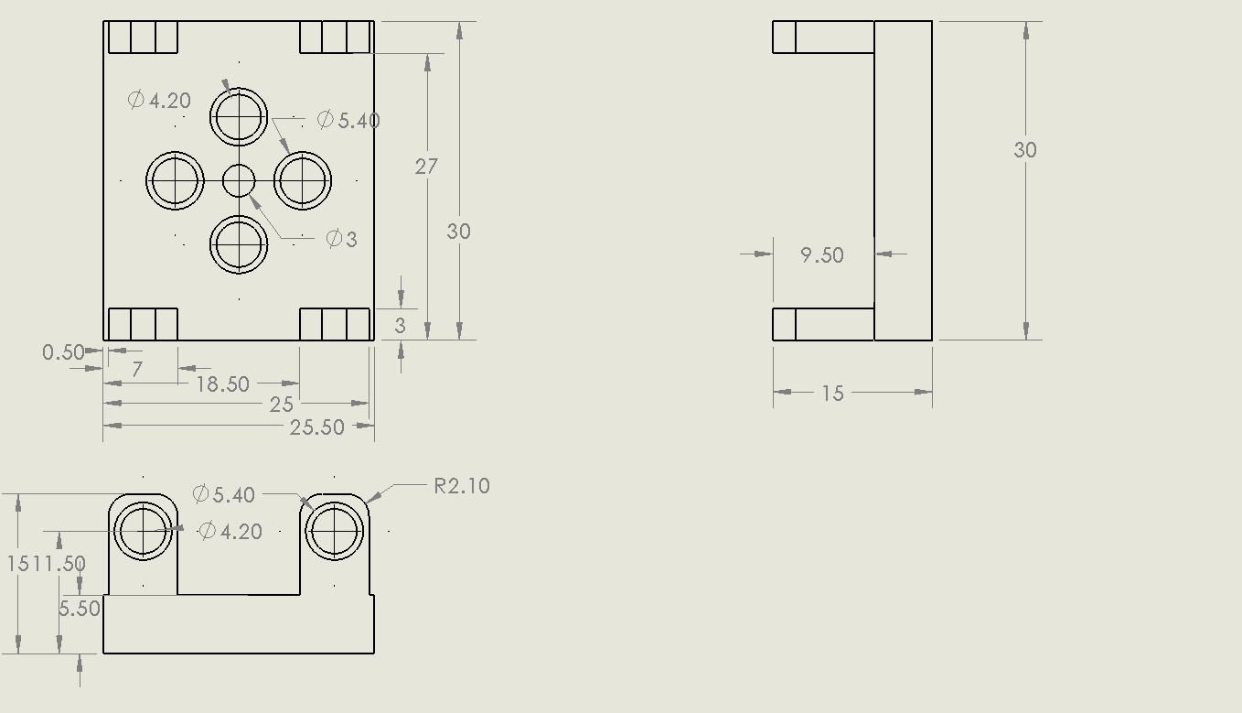

Ellipse with spacer

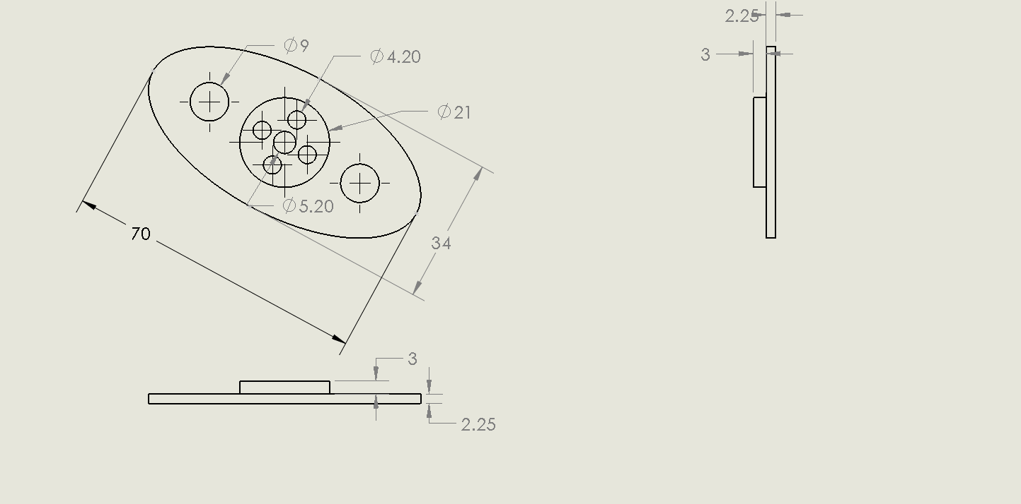

Gripper hand

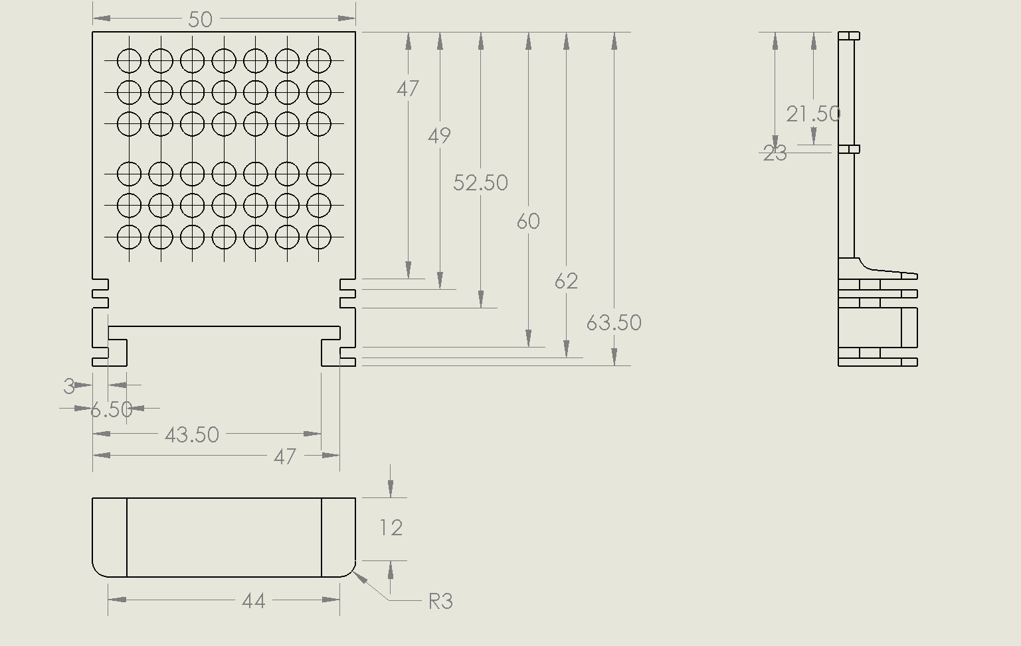

Rail

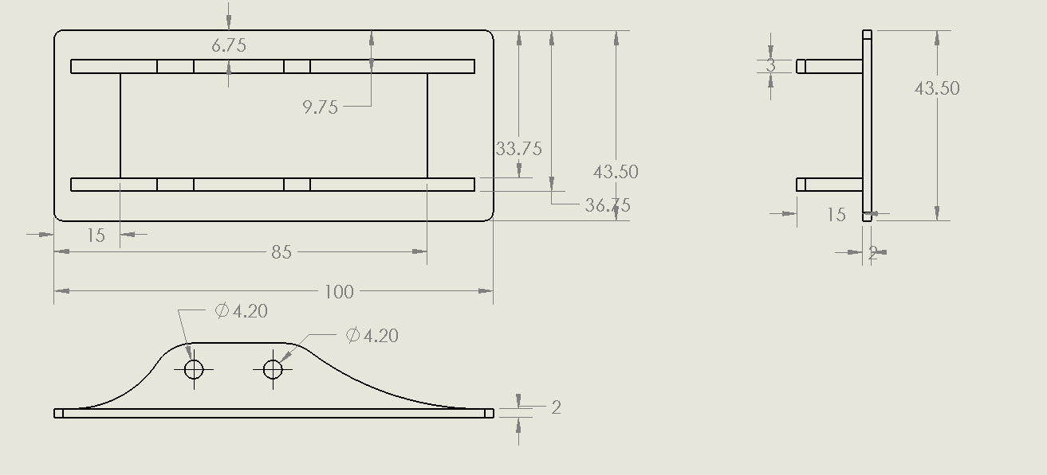

1.